|  |  |  |
| --- | --- | --- |
| Related image | **KONERU LAKSHMAIAH EDUCATION FOUNDATION**  (Deemed to be University estd, u/s, 3 of the UGC Act, 1956)  (NAAC Accredited “A++” Grade University)  Green Fields, Guntur District, A.P., India – 522502 |  |

**AI&ML 23AD2001O – CO-3**

**Practice Problems**

1. Performance Metrics:
2. IRIS dataset

Observe the following Confusion matrices for the IRIS dataset prediction model compute Accuracy, Precision, recall, F1-Score, sensitivity, Specificity.

|  |  |  |  |  |
| --- | --- | --- | --- | --- |
| Predicted |  | Actual | | |
| IRIS-DATASET | Setosa | Versicolor | Verginika |
| Setosa | 98 | 42 | 10 |
| Versicolor | 30 | 105 | 15 |
| Verginika | 17 | 31 | 102 |

1. Heart Disease dataset

Observe the following Confusion matrices for the IRIS dataset prediction model compute Accuracy, Precision, recall, F1-Score, sensitivity, TP rate, FP rate, Area under curve, Specificity.

|  |  |  |  |
| --- | --- | --- | --- |
|  | | Actual | |
| Predicted |  | True | False |
| True | 86 | 12 |
| False | 10 | 79 |

1. Construct the Decision Tree for the following Data sets by using the ID3 Algorithm.

a)

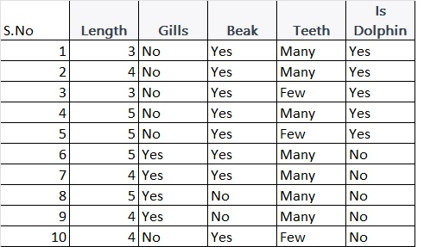

b)

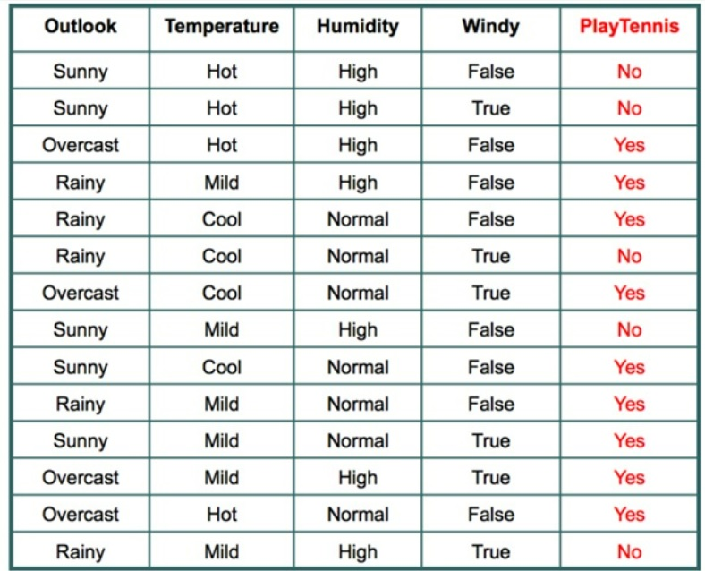

C)

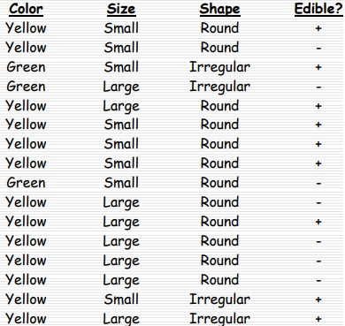

1. Apply the Bayesian Belief Network technique for the given events and probabilities, answer

the following questions.

1. Given that patient has cancer, what is the probability he or she has the positive x-ray?
2. Given that a patient has Dyspnea, what is the probability that he or she is a smoker?

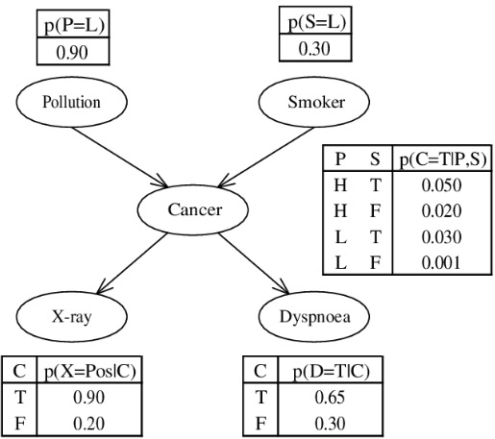

1. Apply the Bayesian Belief Network technique for the given events and probabilities, If P(J/A) =0.90 and P(J/¬A) =0.05 for Alarm answer the following questions.

a) What is the probability that the alarm has sounded but neither a burglary nor an earthquake

has occurred, and both John & Mary call?

b) What is the probability that Mary call?

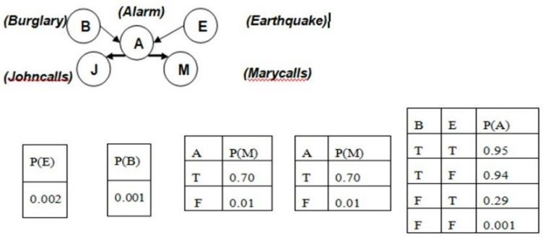

4. Consider the following probabilities and find whether the player plays tennis or not for today = (Sunny, Hot, Normal, False)

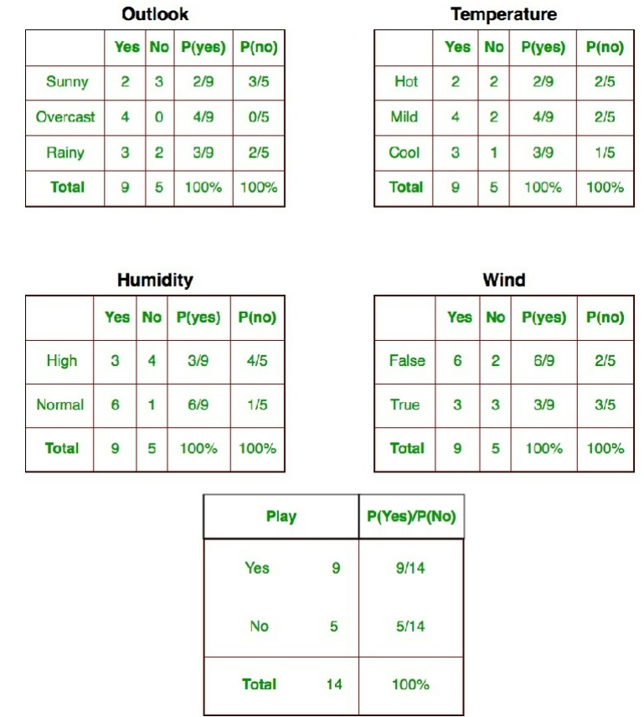

1. 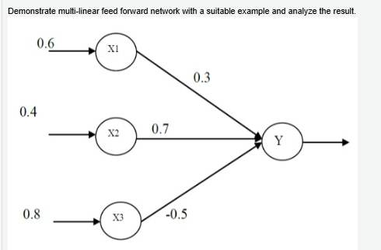
2. 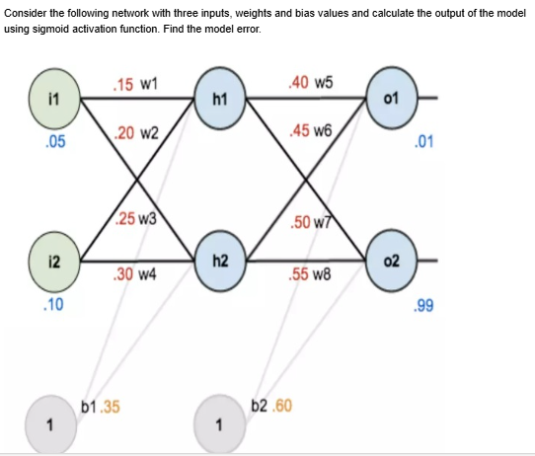
3. Implement k-means clustering algorithm where k=2 on the following data points by considering (1,2,3) and (4,5,6) as random seeds: • (1, 2, 3) • (4, 5, 6) • (2, 3, 4) • (5, 6, 7) • (3, 4, 5) • (6, 7, 8) and analyze the results.
4. Group the following data into 3 clusters using Agglomerative clustering data = A1(2,3), A2(5,3),A3(6,4), A4(8,5), A5(9,4), A6(1,3).
5. 